|  |  |
| --- | --- |
| No. of Pages | 2 |
| No. of Questions | 8 |

**Student Name: _____________________________ID:____________________**

**Department of Computer Science and Engineering**

**Makeup Midterm Examination FALL 2015**

**CSE420: Compiler Design**

**Total Marks: 40 Time Allowed: 1 Hour**

|  |
| --- |
| * You HAVE TO RETURN this question paper and the answer script at the end of the exam. Your script will not be checked unless you do so. * You are not allowed to communicate with any other candidate in any way what so ever. |

**Section A**

1. What would the transition diagram (TD) for **strings containing each vowel**, in their **strict lexicographical order**, look like? [4]

2. Define **Analysis-Synthesis model** of compilation? [2]

3. Convert following NFA to DFA using **subset construction methodology**. [8]

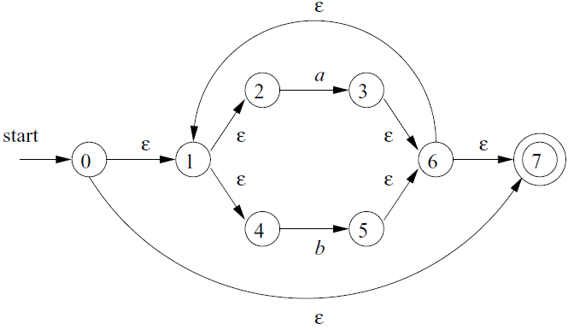

4. Consider the following grammar: [3 + 3]

S SS+ | SS* | a

1. Do a **top-down** **leftmost** derivation of “aa + a*”.
2. Do a **bottom-up** **rightmost** parse tree of “aa + a*”.

5. Define **Handle**. [2]

6. **Left factor** following grammar: [1+1]

A -> α β | α γ

Remove **Left recursion** from following grammar:

A -> A + B | B

B -> int | (A)

**Section B**

7. Determine the **LR(1) automation** and **parse table** for following grammar.

S → A

S → xb

A → aAb

A → B

B → b [5+5]

8. **Parse** input string “**baaab”** using following grammar and parsing table:

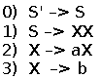 [6]

